 | 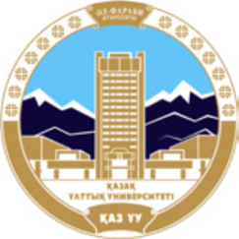 | 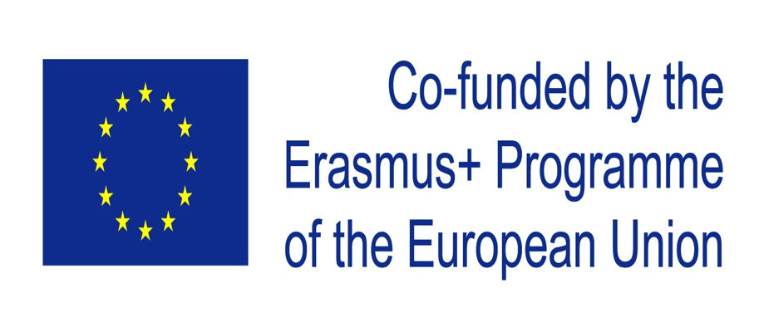

ERASMUS+ / "Engineering Educators Pedagogical Training"- ENTER

Al-Farabi Kazakh National University
September 18 - 21, 2019
Almaty, Kazakhstan

Agenda of meeting

WS1.2 - Workshop on ENTER QMS and procedures

WS2.1 - Workshop on iPET course development

INFORMATION FOR PARTICIPANTS
Travelling to Almaty

Airport Transfer
If travelling by plane, there are two ways to get to the city center (hotel or al-Farabi KazNU).
By public transportation – bus 79, it takes about 2 hours to get Hotel Best Western Plus Atakent Park Hotel****, and about 1 hour 20 minutes to get Astana International Hotel****. It is a better to consult with application: https://2gis.kz/almaty?queryState=center%2F76.945298%2C43.238478%2Fzoom%2F12%2FrouteTab or contact us for detailed information.
Also you can get taxi (yandex or uber)

Accommodation

Hotel Best Western Plus Atakent Park Hotel**** (Timiryazev Street 42, 050057 Almaty, Kazakhstan). KazNU is located 1,6 km away (a 20-25 min walk, by social transport 5 min) from this hotel .http://aphotel.kz

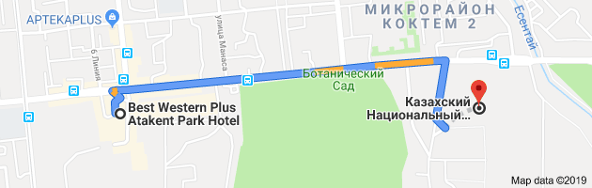

Hotel Astana International Hotel**** (Baitursynova Street 113, 050022 Almaty, Kazakhstan).KazNU is located 2,5km away (by social transport #11,9,7trolley buses, # 30, 79for 150 kzt (⁓0.30 euro) 15-20 min, by taxi 1000 kzt (⁓2,5 euro) 10-15 min) from this hotel.

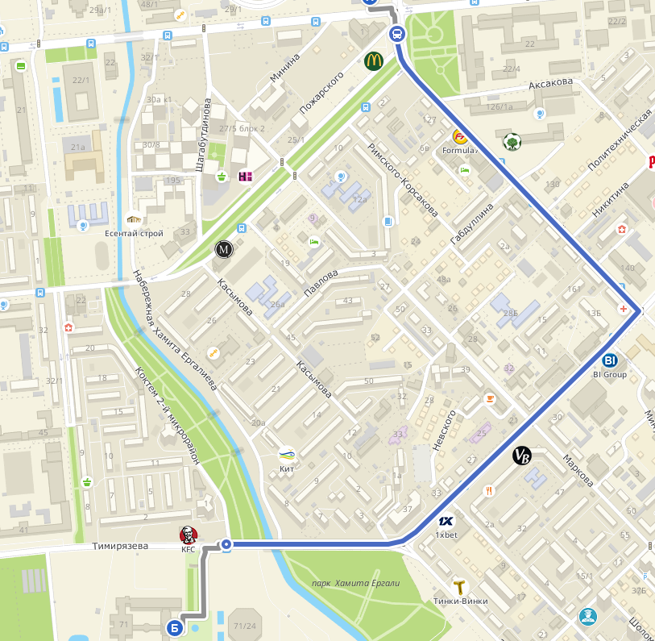
Mildom Hotel, Mildom Premium
Address: Bogenbai Batyr Street 128, Almaty

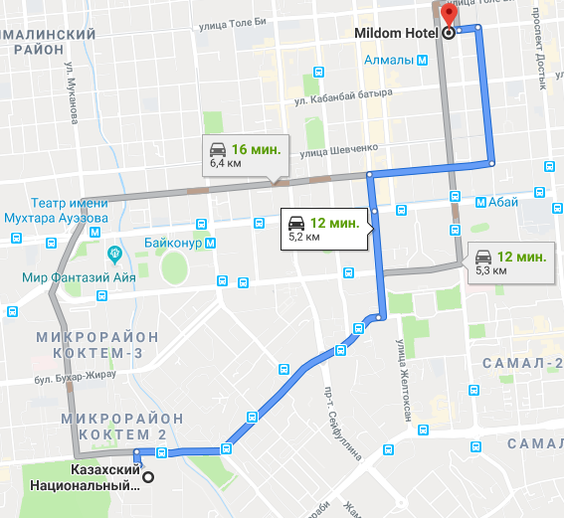
Meeting Venue: al-Farabi Kazakh National University, 71, al-Farabi ave, Library, room 411

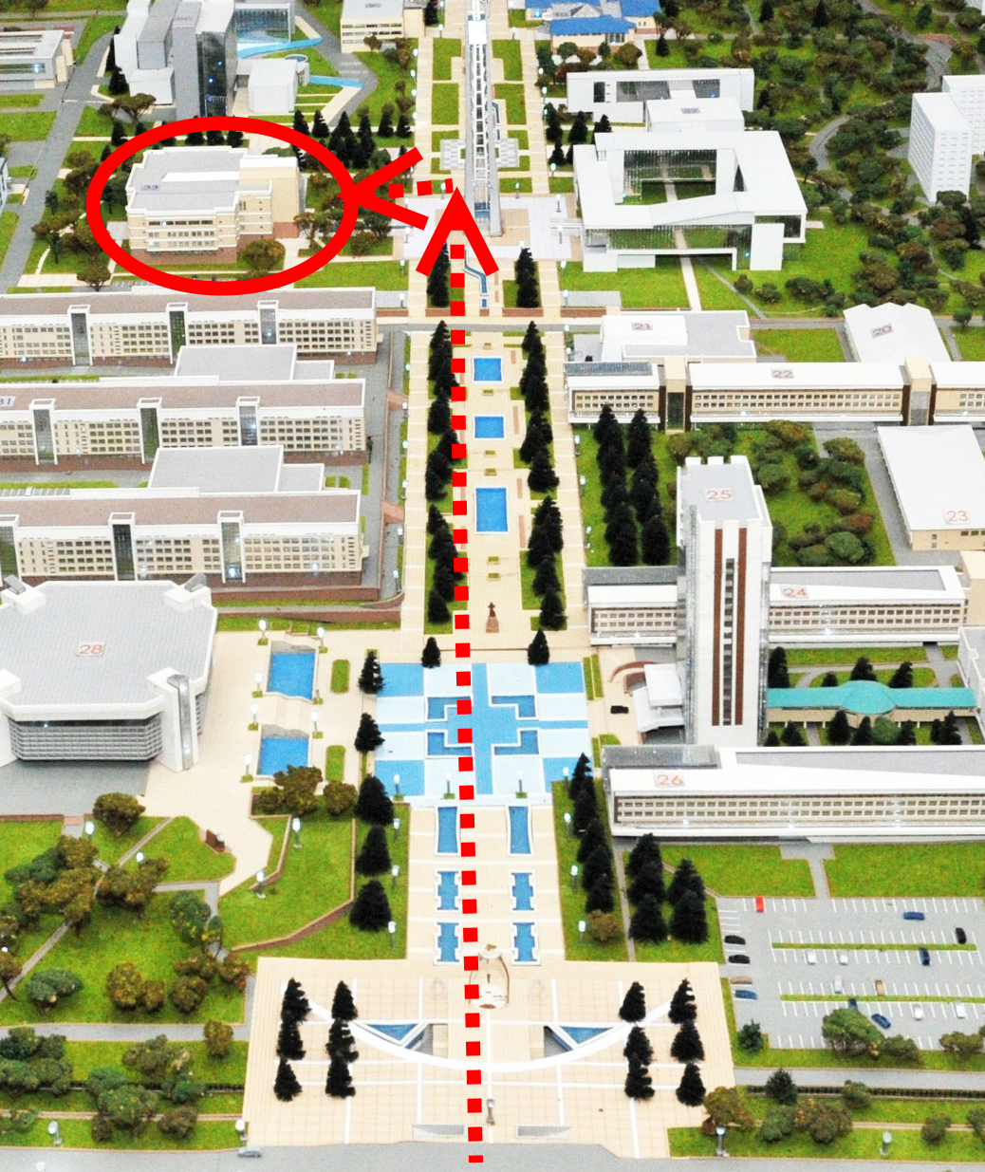

For further information, please, contact Kuralay Nurgaliyeva (kdungen@gmail.com; tel + 7 7078289010)

Wednesday18thSeptember 2019
Arrival of participants to Almaty, accommodation
Venue: al-Farabi Kazakh National University
71, al-Farabi ave
Library, room 411
10.00-10:30 | Welcome to the ENTER project participants by the KazNU authorities | Welcome of:  First Vice Rector of al-Farabi KazNU  Burkitbayev M.M.  Dean of the Department  of Physics and Technology  Davletov A.E.
Campus tour

Thursday 19th September 2019
Venue: al-Farabi Kazakh National University
71, al-Farabi ave
Library, room 411
09.00 - 10.00 | Registration
10.00 - 10.10 | Organizing Committee Greetings  Opening of the ENTER Project meeting | KazNU
10.10 – 10.30 | NEO Kazakhstan Greeting | Welcome of:  NEO in Kazakhstan director  Tasbulatova Sh.U.
10.30 – 11.00 | Summary of WP1 | DSTU
11.00 – 11.40 | WP2 «Draft of Engineering Educators Pedagogical Training Programmes (iPET-1, iPET-2, iPET-3)» | TPU
11.40 – 12.00 | Coffee Break
12.00 – 12.30 | WP3 – External body definition | TSTU
12.30- 13.00 | WP4: Dissemination results | AEER, Bologna Club, KazSEE
13.00-14.30 | Lunch | At your own expenses
14.30 – 17.00 | Workshop on iPET course development | TPU
17.00-17.30 | Coffee Break
17.30 – 18.30 | Workshop on iPET course development (continue) | TPU
19.00 | Social dinner | Restaurant to be confirmed

Friday 20th September 2019
Venue: al-Farabi Kazakh National University
71, al-Farabi ave
Library, room 411
Time | Content | Proposed presenters
09.00 – 11.00 | Workshop on ENTER QMS and procedures | TSTU
11.00 – 11.30 | Coffee Break
11.30 -13.00 | Workshop on ENTER QMS and procedures (continue) | TSTU
11.30 – 12.30 | Presentation on the QS Worldwide meeting ‘Journeq to GlobalProminence:Harmony of Human Heritage and Advanced Technology’ Track 4: Higher Education, Culture& Technology Developments along the Silk Road  Increasing the individual creative engagement towards the sustainable development tgoals implementation | Jose Carlos Quadrado  P.Porto
13.00-14.30 | Lunch | At your own expenses
14.30-16.30 | Project meeting: Networking design (how ENTER will integrate and expend in the future) | Discussion
16:30 – 17:00 | Management Board meeting | Decision making
18.00 | Informal dinner | At your own expenses

Saturday 21th September 2019
Venue: al-Farabi Kazakh National University
71, al-Farabi ave
Library, room 411
Time | Content
09.00-10:00 | ENTER project Status Quo | Next steps in all WPs implementation
10.00-11.00 | Closing and conclusions
11.00 - __ | Mountain tour | At your own expenses

